2017-2018 Board  Co-Chairs  Paul G. Johnson, Esq.  Jennings Strouss & Salmon Melissa Sanderson  Freeport McMoRan Inc.  President  Brett W. Johnson, Esq.  Snell & Wilmer, LLP  Vice President  Andrew Jaynes, ASU  ASU Law School  Secretary/Treasurer  Karen Gill Meyer  Morgan Stanley  Directors  Matthew Apfel  Apfel and Associates  James Arrowood  Arrowood Attorneys  Paul Arutt  Heritage West Capital Corp.  Alana Chavez-Langdon  Arizona Public Service  Ambassador (ret.) Douglas A.  Hartwick, Consultant  Joan Jordan  Sanford Rose Associates  Adam McAnally  Salt River Project  Claire Merkel  The McCain Institute  Michael Patterson  Polsinelli PC  Steven Ranes  Arizona Public Service  Steve Rodis  Wallace, Plese + Dreher, LLP  John Salinger  Sarah Suggs  O’Connor Institute  Ex-Officio Board Members  Barbara Dawson  Snell & Wilmer LLP  Douglas Sylvester  ASU College of Law  Emeritus Board Members  Keith Galbut  Ed Kirdar  Stephen MacKinnon  JP Millon  Susan Shultz  Shoshana Tancer  Membership Chair  Joan Jordan  Program Chair  Andrew Jaynes  PR Chair  James Arrowood  Executive Director  Conni Ingallina  7949 E. Acoma Drive, #207  Scottsdale, AZ 85260  - 602.441-4967  Fax: 480.289.5765  conni@pcfraz.org  www.pcfraz.org | Dear Colleague:  As you may know, each year the Phoenix Committee on Foreign Relations (PCFR) hosts the International State of the State event to focus on Arizona’s role in the global community. This program features the Arizona Governor providing insight as to Arizona’s comparative position and what the future holds for new opportunities.  This year’s dinner event will be held on February 20, 2018. We will have the unique opportunity to host not only the Arizona Governor, but two high-level diplomats from Canada and Mexico who will be joining Governor Ducey for a panel discussion on issues facing North American and the international community.  In addition, this event will occur the night before ASU’s Summit titled “Redefining Trade: A New Vision for Competitiveness & Prosperity” that will be held on February 21st. This invitation only event will include leading academics, elected leaders, and corporate heads from around the world to continue the dialogue started at the International State of the State. The ASU invited speakers will also attend the dinner and allow additional interaction to an impressive array of business, academic, and policy makers.  We want to give you and your organization the opportunity to become involved with ensuring an amazing event to highlight Arizona’s role in the ever-changing world. We have four levels of sponsorship available, including the opportunity to be a title sponsor and being able to sit at the head table with our VIP guests, participating in a VIP reception, and having a VIP also sit at your table. I have attached a sponsorship form for your consideration.  We are excited about this event, as we continue to elevate Arizona’s place in the world.  Sincerely,  Brett Johnson  Brett Johnson  President, Phoenix Committee on Foreign Relations
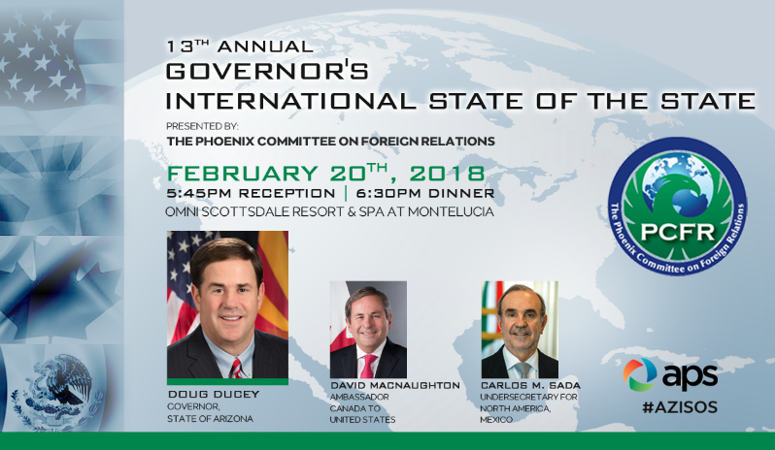

13th Annual International State of the State
Sponsor Opportunities
Tuesday, February 20, 2018
5:30pm – 8:30pm
FOUR SPONSOR LEVELS TO CHOOSE FROM:
Title Sponsor - $15,000
- Prominent logo recognition in all materials, program, signage and website
- Recognition in opening remarks
- Branding on Invitations
- Table of 10 at the February 20th Dinner
- Priority table placement
- 2 seats at the head table
- 10 tickets to VIP event
- Title Sponsor would make the introduction of the Arizona Global Honorary Awardee
Event Sponsor - $7,500
- Prominent logo recognition in all materials, program, signage and website
- Recognition in opening remarks
- Branding on Invitations
- Table of 10 at the February 20th Dinner
- Priority table placement
- 10 tickets to VIP event
- Option for VIP to be assigned to table
Corporate Sponsor - $5,000
- Prominent logo recognition in all materials, program, signage and website
- Recognition in opening remarks
- Branding on Invitations
- Table of 10 at the February 20th Dinner
- Priority table placement
- 5 tickets to VIP event
- Option for VIP to be assigned to table
Table Sponsor - $2,500
- Logo recognition at event
- Table of 10 at the February 20th Dinner
- 2 tickets to the VIP event

PLEASE NOTE: Send your table names to: events@pcfraz.org
Deadline for name submission is February 10, 2018

SPONSOR INFORMATION:
Company Name: ___________________________Contact _____________________________________
Address: _________________________________City, State & Zip: _____________________________
Telephone: ___________________________E-Mail: __________________________________________
PAYMENT INFORMATION: __Title-$15,000; _ Event-$7,500; Corporate-$5,000; Table-$2,500
Amount enclosed $________ Check # ________
Send to: PCFR, 7949 E. Acoma Drive #207, Scottsdale, AZ 85260

Credit Card Type: (circle one) MC VISA AMEX
Name on Card ______________________________________
Credit Card # _______________________________________Exp __________ Sec Code ______
Address: _____________________________________________________City/State/Zip__________________________

NAME | COMPANY | TITLE | EMAIL
ISOS TABLE NAMES:

Please Note: Table Placement will be based on a “first come, first paid” basis, when you pay in full. We will do our best to put all of our sponsors in the most advantageous places possible.

